Uncountable Noun

🔹 What is Uncountable Noun
# Source: AI Source: Provided by: [Data Path: Persons Table -> ID Column: 1, Name_En Column: Motasem Essam] -> From: [Chatgpt (GPT-4-turbo)] on [7/26/2025]
An uncountable noun is a noun that refers to something you cannot count as separate units.
✨ It represents a mass, a substance, or an abstract concept that is not divided into individual parts.

✅ Definition:
# Source: AI Source: Provided by: [Data Path: Persons Table -> ID Column: 1, Name_En Column: Motasem Essam] -> From: [Chatgpt (GPT-4-turbo)] on [7/26/2025]
Uncountable nouns refer to things that are seen as a whole or mass, and cannot be counted directly (you don’t say "one sugar" or "two informations").

🧠 Examples of Uncountable Nouns:
# Source: AI Source: Provided by: [Data Path: Persons Table -> ID Column: 1, Name_En Column: Motasem Essam] -> From: [Chatgpt (GPT-4-turbo)] on [7/26/2025]
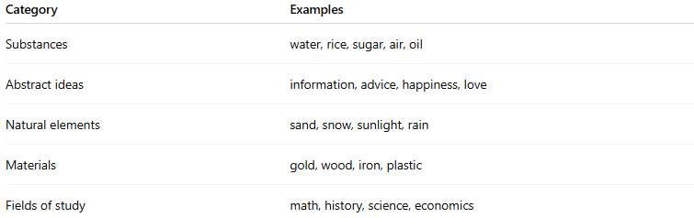
Category | Examples
Substances | water, rice, sugar, air, oil
Abstract ideas | information, advice, happiness, love
Natural elements | sand, snow, sunlight, rain
Materials | gold, wood, iron, plastic
Fields of study | math, history, science, economics

📝 Example Sentences:
# Source: AI Source: Provided by: [Data Path: Persons Table -> ID Column: 1, Name_En Column: Motasem Essam] -> From: [Chatgpt (GPT-4-turbo)] on [7/26/2025]
- She gave me useful advice.
- There is milk in the fridge.
- We need more information about the topic.
- I don’t have enough money.

⚠️ Important Notes:
# Source: AI Source: Provided by: [Data Path: Persons Table -> ID Column: 1, Name_En Column: Motasem Essam] -> From: [Chatgpt (GPT-4-turbo)] on [7/26/2025]
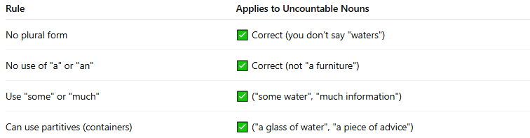
Rule | Applies to Uncountable Nouns
No plural form | ✅ Correct (you don’t say "waters")
No use of "a" or "an" | ✅ Correct (not "a furniture")
Use "some" or "much" | ✅ ("some water", "much information")
Can use partitives (containers) | ✅ ("a glass of water", "a piece of advice")

🔄 Opposite: Countable Nouns
# Source: AI Source: Provided by: [Data Path: Persons Table -> ID Column: 1, Name_En Column: Motasem Essam] -> From: [Chatgpt (GPT-4-turbo)] on [7/26/2025]
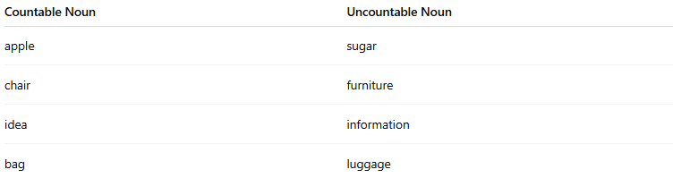
Countable Noun | Uncountable Noun
apple | sugar
chair | furniture
idea | information
bag | luggage

📘 Countable Nouns vs. Uncountable Nouns
# Source: AI Source: Provided by: [Data Path: Persons Table -> ID Column: 1, Name_En Column: Motasem Essam] -> From: [Chatgpt (GPT-4-turbo)] on [7/26/2025]
Both are types of common nouns, but they refer to different kinds of things depending on whether they can be counted or not.

🔹 1. Countable Nouns
# Source: AI Source: Provided by: [Data Path: Persons Table -> ID Column: 1, Name_En Column: Motasem Essam] -> From: [Chatgpt (GPT-4-turbo)] on [7/26/2025]
- Refer to individual items that can be counted
- Have singular and plural forms
- Can use "a/an", numbers, many, few"
Examples:
- book, apple, cat, chair, idea

🔹 2. Uncountable Nouns
# Source: AI Source: Provided by: [Data Path: Persons Table -> ID Column: 1, Name_En Column: Motasem Essam] -> From: [Chatgpt (GPT-4-turbo)] on [7/26/2025]
- Refer to things you cannot count as separate units
- Do not have a plural form
- Use "some", "much", "a little" (not "a/an")
- Often refer to substances or abstract concepts
Examples:
- water, sugar, information, advice, rice

🧠 Comparison Table:
# Source: AI Source: Provided by: [Data Path: Persons Table -> ID Column: 1, Name_En Column: Motasem Essam] -> From: [Chatgpt (GPT-4-turbo)] on [7/26/2025]
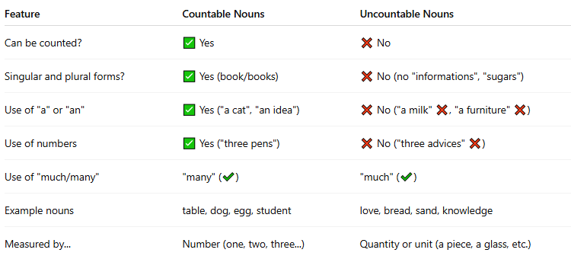
Feature | Countable Nouns | Uncountable Nouns
Can be counted? | ✅ Yes | ❌ No
Singular and plural forms? | ✅ Yes (book/books) | ❌ No (no "informations", "sugars")
Use of "a" or "an" | ✅ Yes ("a cat", "an idea") | ❌ No ("a milk" ❌, "a furniture" ❌)
Use of numbers | ✅ Yes ("three pens") | ❌ No ("three advices" ❌)
Use of "much/many" | "many" (✔) | "much" (✔)
Example nouns | table, dog, egg, student | love, bread, sand, knowledge
Measured by... | Number (one, two, three...) | Quantity or unit (a piece, a glass, etc.)

📝 Example Sentences:
# Source: AI Source: Provided by: [Data Path: Persons Table -> ID Column: 1, Name_En Column: Motasem Essam] -> From: [Chatgpt (GPT-4-turbo)] on [7/26/2025]
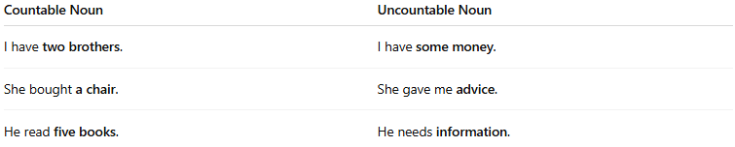
Countable Noun | Uncountable Noun
I have two brothers. | I have some money.
She bought a chair. | She gave me advice.
He read five books. | He needs information.

✅ Tip to Remember:
# Source: AI Source: Provided by: [Data Path: Persons Table -> ID Column: 1, Name_En Column: Motasem Essam] -> From: [Chatgpt (GPT-4-turbo)] on [7/26/2025]
- If you can count it (1, 2, 3…), it’s countable
- If you measure it (some, a lot, a little…), it’s uncountable

Partitives

🔹 Partitives – What Are They?
# Source: AI Source: Provided by: [Data Path: Persons Table -> ID Column: 1, Name_En Column: Motasem Essam] -> From: [Chatgpt (GPT-4-turbo)] on [7/26/2025]
A partitive is a word or phrase used to refer to a part, amount, or quantity of something — especially with uncountable nouns or mass nouns.
✨ It allows us to count or measure uncountable things by breaking them into countable units.

✅ Definition:
# Source: AI Source: Provided by: [Data Path: Persons Table -> ID Column: 1, Name_En Column: Motasem Essam] -> From: [Chatgpt (GPT-4-turbo)] on [7/26/2025]
A partitive is an expression that helps you measure or count a portion of an uncountable noun.

🧱 Structure:
# Source: AI Source: Provided by: [Data Path: Persons Table -> ID Column: 1, Name_En Column: Motasem Essam] -> From: [Chatgpt (GPT-4-turbo)] on [7/26/2025]
Partitive word/phrase + "of" + uncountable noun
🧠 You're not counting the noun directly — you're counting a unit of it.

📚 Common Partitive Examples:
# Source: AI Source: Provided by: [Data Path: Persons Table -> ID Column: 1, Name_En Column: Motasem Essam] -> From: [Chatgpt (GPT-4-turbo)] on [7/26/2025]
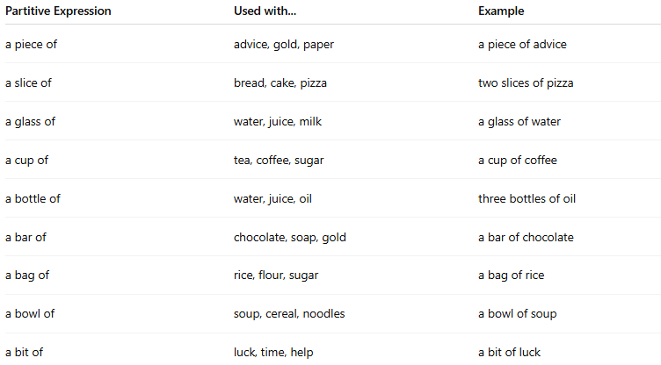

Partitive Expression | Used with... | Example
a piece of | advice, gold, paper | a piece of advice
a slice of | bread, cake, pizza | two slices of pizza
a glass of | water, juice, milk | a glass of water
a cup of | tea, coffee, sugar | a cup of coffee
a bottle of | water, juice, oil | three bottles of oil
a bar of | chocolate, soap, gold | a bar of chocolate
a bag of | rice, flour, sugar | a bag of rice
a bowl of | soup, cereal, noodles | a bowl of soup
a bit of | luck, time, help | a bit of luck

📝 Example Sentences:
# Source: AI Source: Provided by: [Data Path: Persons Table -> ID Column: 1, Name_En Column: Motasem Essam] -> From: [Chatgpt (GPT-4-turbo)] on [7/26/2025]
- I had a glass of milk before bed.
- She gave me a piece of advice.
- We need two slices of bread.
- He bought a bag of sugar.

🚫 Without Partitives (Incorrect with Uncountables):
# Source: AI Source: Provided by: [Data Path: Persons Table -> ID Column: 1, Name_En Column: Motasem Essam] -> From: [Chatgpt (GPT-4-turbo)] on [7/26/2025]
- ❌ “I want two waters.”
✅ “I want two bottles of water.”
- ❌ “She gave me an information.”
✅ “She gave me a piece of information.”

✅ Summary:
# Source: AI Source: Provided by: [Data Path: Persons Table -> ID Column: 1, Name_En Column: Motasem Essam] -> From: [Chatgpt (GPT-4-turbo)] on [7/26/2025]
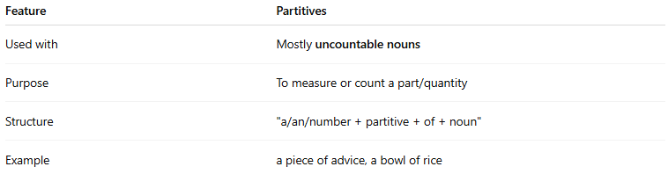
Feature | Partitives
Used with | Mostly uncountable nouns
Purpose | To measure or count a part/quantity
Structure | "a/an/number + partitive + of + noun"
Example | a piece of advice, a bowl of rice

✅ Summary:
# Source: AI Source: Provided by: [Data Path: Persons Table -> ID Column: 1, Name_En Column: Motasem Essam] -> From: [Chatgpt (GPT-4-turbo)] on [7/26/2025]
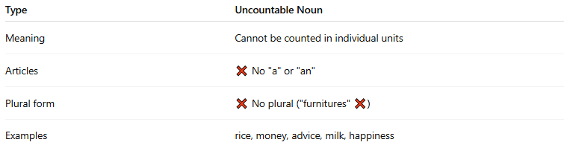
Type | Uncountable Noun
Meaning | Cannot be counted in individual units
Articles | ❌ No "a" or "an"
Plural form | ❌ No plural ("furnitures" ❌)
Examples | rice, money, advice, milk, happiness

